# **Full Stack Development with MERN**

### Project Name

## OrderOnTheGo

## Your On-Demand Food Ordering Solution

### Submitted by

**Team Id :** LTVIP2025TMID59338

**Team Members**

Ojeswari Devi kilari - Frontend Developer

Abhinaya Kalisetty - Backend Developer

Harini Kanna - UI/UX Designer

## 1.INTRODUCTION

### Introducing CraveKart, the cutting-edge digital platform poised to revolutionize the way you order food online. With CraveKart, your food ordering experience will reach unparalleled levels of convenience and efficiency.

### Our user-friendly web app empowers foodies to effortlessly explore, discover, and order dishes tailored to their unique tastes. Whether you're a seasoned food enthusiast or an occasional diner, finding the perfect meals has never been more straightforward.

### Imagine having comprehensive details about each dish at your fingertips. From dish descriptions and customer reviews to pricing and available promotions, you'll have all the information you need to make well-informed choices. No more second-guessing or uncertainty – CraveKart ensures that every aspect of your online food ordering journey is crystal clear.

### The ordering process is a breeze. Just provide your name, delivery address, and preferred payment method, along with your desired dishes. Once you place your order, you'll receive an instant confirmation. No more waiting in long queues or dealing with complicated ordering processes – CraveKart streamlines it, making it quick and hassle-free.

## **1.1 SCENARIO:**

**Late-Night Craving Resolution**

Meet Lisa, a college student burning the midnight oil to finish her assignment. As the clock strikes midnight, her stomach grumbles, reminding her that she skipped dinner. Lisa doesn't want to interrupt her workflow by cooking, nor does she have the energy to venture outside in search of food.

Solution with Food Ordering App:

1. Lisa opens the Food Ordering App on her smartphone and navigates to the late-night delivery section, where she finds a variety of eateries still open for orders.

2. She scrolls through the options, browsing menus and checking reviews until she spots her favorite local diner offering comfort food classics.

3. Lisa selects a hearty bowl of chicken noodle soup and a side of garlic bread, craving warmth and satisfaction in each bite.

4. With a few taps, she adds the items to her cart, specifies her delivery address, and chooses her preferred payment method.

5. Lisa double-checks her order details on the confirmation page, ensuring everything looks correct, before tapping the "Place Order" button.

6. Within minutes, she receives a notification confirming her order and estimated delivery time, allowing her to continue working with peace of mind.

7. As promised, the delivery arrives promptly at her doorstep, and Lisa eagerly digs into her piping hot meal, grateful for the convenience and comfort provided by the Food Ordering App during her late-night study session.

This scenario illustrates how a Food Ordering App caters to users' needs, even during unconventional hours, by offering a seamless and convenient solution for satisfying late-night cravings without compromising on quality or convenience.

## PROJECT OVERVIEW

**2.1 PURPOSE**

The purpose of the OrderOnTheGo project is to build a user-friendly, full-stack online food ordering platform that connects customers with local restaurants. The goal is to streamline the process of discovering restaurants, placing food orders, and managing them efficiently. It aims to provide seamless experiences for customers, restaurant owners, and administrators, ensuring quick access to food, better order tracking, and efficient restaurant management.

## 2.2 FEATURES:

1. **Comprehensive Product Catalog:** CraveKart boasts an extensive catalog of food items from various restaurants, offering a diverse range of items and options for shoppers. You can effortlessly explore and discover various products, complete with detailed descriptions, customer reviews, pricing, and available discounts, to find the perfect food for your hunger.

2. **Order Details Page**: Upon clicking the "Place Order" button, you will be directed to an order details page. Here, you can provide relevant information such as your shipping address, preferred payment method, and any specific product requirements.

3. **Secure and Efficient Checkout Process:** CraveKart guarantees a secure and efficient checkout process. Your personal information will be handled with the utmost security, and we strive to make the purchasing process as swift and trouble-free as possible.

4. **Order Confirmation and Details:** After successfully placing an order, you will receive a confirmation notification. Subsequently, you will be directed to an order details page, where you can review all pertinent information about your order, including shipping details, payment method, and any specific product requests you specified.

In addition to these user-centric features, CraveKart provides a robust restaurant dashboard, offering restaurants an array of functionalities to efficiently manage their products and sales. With the restaurant dashboard, restaurants can add and oversee multiple product listings, view order history, monitor customer activity, and access order details for all purchases.

CraveKart is designed to elevate your online food ordering experience by providing a seamless and user-friendly way to discover your desired foods. With our efficient checkout process, comprehensive product catalog, and robust restaurant dashboard, we ensure a convenient and enjoyable online shopping experience for both shoppers and restaurants alike.

## 

## ARCHITECTURE

## 3.1 TECHNICAL ARCHITECTURE:

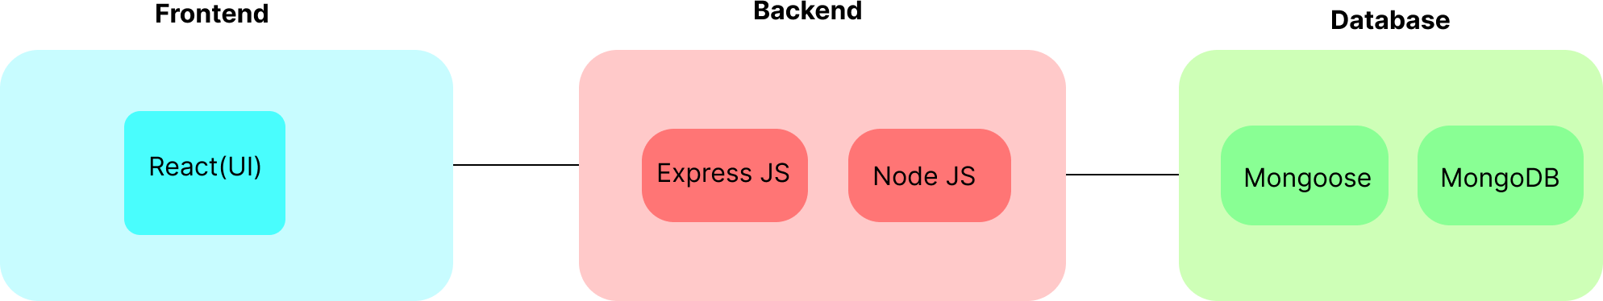

In this architecture diagram:

• The frontend is represented by the "Frontend" section, including user interface components such as User Authentication, Cart, Products, Profile, Admin dashboard, etc.,

• The backend is represented by the "Backend" section, consisting of API endpoints for Users, Orders, Products, etc., It also includes Admin Authentication and an Admin Dashboard.

• The Database section represents the database that stores collections for Users, Admin, Cart, Orders, and products.

## 3.2 ER DIAGRAM

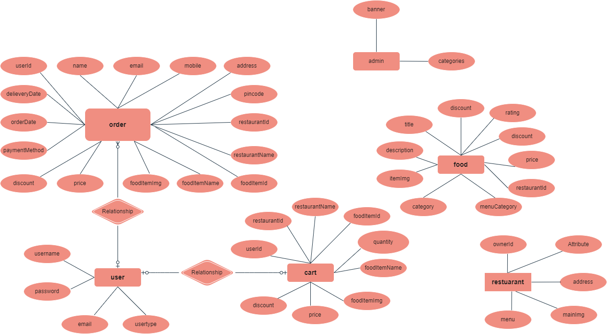

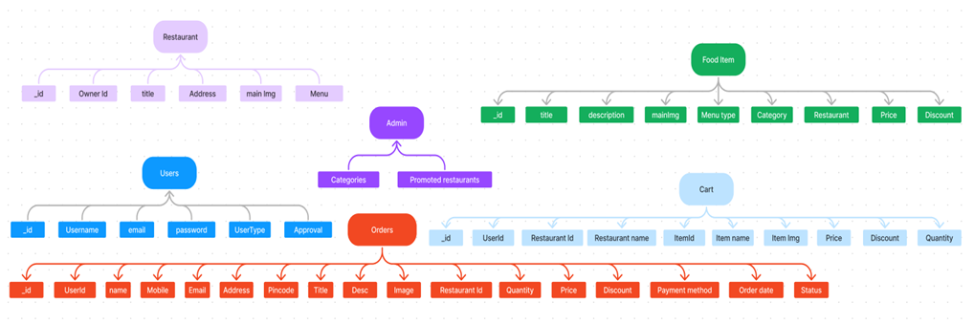

The CraveKart ER-diagram represents the entities and relationships involved in an food ordering e-commerce system. It illustrates how users, restaurants, products, carts, and orders are interconnected. Here is a breakdown of the entities and their relationships:

**User:** Represents the individuals or entities who are registered in the platform.

**Restaurant**: This represents the collection of details of each restaurant in the platform.

**Admin:** Represents a collection with important details such as promoted restaurants and Categories.

**Products:** Represents a collection of all the food items available in the platform.

**Cart:** This collection stores all the products that are added to the cart by users. Here, the elements in the cart are differentiated by the user Id.

**Orders:** This collection stores all the orders that are made by the users in the platform.

## 

## 4.SETUP INSTRUTIONS

## 4.1 PREREQUISITES:

To develop a full-stack food ordering app using React JS, Node.js, and MongoDB, there are several prerequisites you should consider. Here are the key prerequisites for developing such an application:

**Node.js and npm:** Install Node.js, which includes npm (Node Package Manager), on your development machine. Node.js is required to run JavaScript on the server side. • Download: https://nodejs.org/en/download/

• Installation instructions: https://nodejs.org/en/download/package-manager/

**MongoDB:** Set up a MongoDB database to store hotel and booking information. Install MongoDB locally or use a cloud-based MongoDB service.

• Download: https://www.mongodb.com/try/download/community

• Installation instructions: https://docs.mongodb.com/manual/installation/

**Express.js:** Express.js is a web application framework for Node.js. Install Express.js to handle server-side routing,middleware, and API development.

• Installation: Open your command prompt or terminal and run the following command: **npm install express**

**React.js**: React.js is a popular JavaScript library for building user interfaces. It enables developers to create interactive and reusable UI components, making it easier to build dynamic and responsive web applications. To install React.js, a JavaScript library for building user interfaces, follow the installation guide: https://reactjs.org/docs/create-a-new-react-app.html

**HTML, CSS, and JavaScript:** Basic knowledge of HTML for creating the structure of your app, CSS for styling,and JavaScript for client-side interactivity is essential.

**Database Connectivity:** Use a MongoDB driver or an Object-Document Mapping (ODM) library like Mongoose to connect your Node.js server with the MongoDB database and perform CRUD (Create, Read, Update, Delete) operations.

**Front-end Framework:** Utilize Angular to build the user-facing part of the application, including product listings, booking forms, and user interfaces for the admin dashboard.

**Version Control**: Use Git for version control, enabling collaboration and tracking changes throughout the development process. Platforms like GitHub or Bitbucket can host your repository.

• Git: Download and installation instructions can be found at: https://git scm.com/downloads

**Development Environment:** Choose a code editor or Integrated Development Environment (IDE) that suits your preferences, such as Visual Studio Code, Sublime Text, or WebStorm.

• Visual Studio Code: Download from https://code.visualstudio.com/download

• Sublime Text: Download from https://www.sublimetext.com/download

• WebStorm: Download from <https://www.jetbrains.com/webstorm/download>

**To Connect the Database with Node JS go through the below provided link:**

Link: https://www.section.io/engineering-education/nodejs- mongoosejs-mongodb/

**To run the existing CraveKart App project downloaded from github:**

Follow below steps:

**Clone the repository:**

• Open your terminal or command prompt.

• Navigate to the directory where you want to store the e-commerce app.

• Execute the following command to clone the repository:

**Git clone: <https://github.com/KalisettyAbhi234/OrderOnTheGo-Your-On-Demand-Food-Ordering-Solution/tree/main>**

## 4.2 INSTALL DEPENDENCIES

• Navigate into the cloned repository directory:

**cd Food-Ordering-App-MERN**

• Install the required dependencies by running the following command:

**npm install**

**Start the Development Server:**

• To start the development server, execute the following command:

**npm run dev or npm run start**

• The e-commerce app will be accessible at http://localhost:3000 by default. You can change the port configuration in the .env file if needed.

**Access the App:**

• Open your web browser and navigate to http://localhost:3000.

• You should see the flight booking app's homepage, indicating that the installation and setup were successful.

You have successfully installed and set up the CraveKart app on your local machine. You can now proceed with further customization, development, and testing as needed.

## 5.FOLDER STRUCTURE

## 5.1 USER & ADMIN FLOW:

**1. User Flow:**

• Users start by registering for an account.

• After registration, they can log in with their credentials.

• Once logged in, they can check for the available products in the platform. • Users can add the products they wish to their carts and order.

• They can then proceed by entering address and payment details. • After ordering, they can check them in the profile section.

**2. Restaurant Flow:**

• Restaurants start by authenticating with their credentials.

• They need to get approval from the admin to start listing the products. • They can add/edit the food items.

**3. Admin Flow:**

• Admins start by logging in with their credentials.

• Once logged in, they are directed to the Admin Dashboard.

• Admins can access the users list, products, orders, etc.

## **5.2 PROJECT STRUCTURE**

This structure assumes a React app and follows a modular approach. Here's a brief explanation of the main directories and files:

• src/components: Contains components related to the application such as, register, login, home, etc.,

• src/pages has the files for all the pages in the application

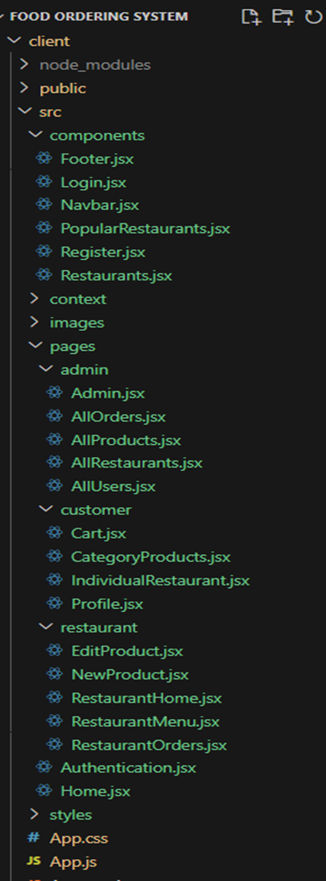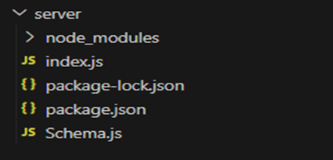

.

## 6.RUNNING THE APPLICATION

## 6.1 PROJECT SETUP AND CONFIGURATION:

**Install required tools and software:**

• Node.js.

Reference Article: <https://www.geeksforgeeks.org/installation-of-node-js-on-windows/>

• Git.

Reference Article: <https://git-scm.com/book/en/v2/Getting-Started-Installing-Git>

**Create project folders and files:**

• Client folders.

• Server folders

Referral Image:

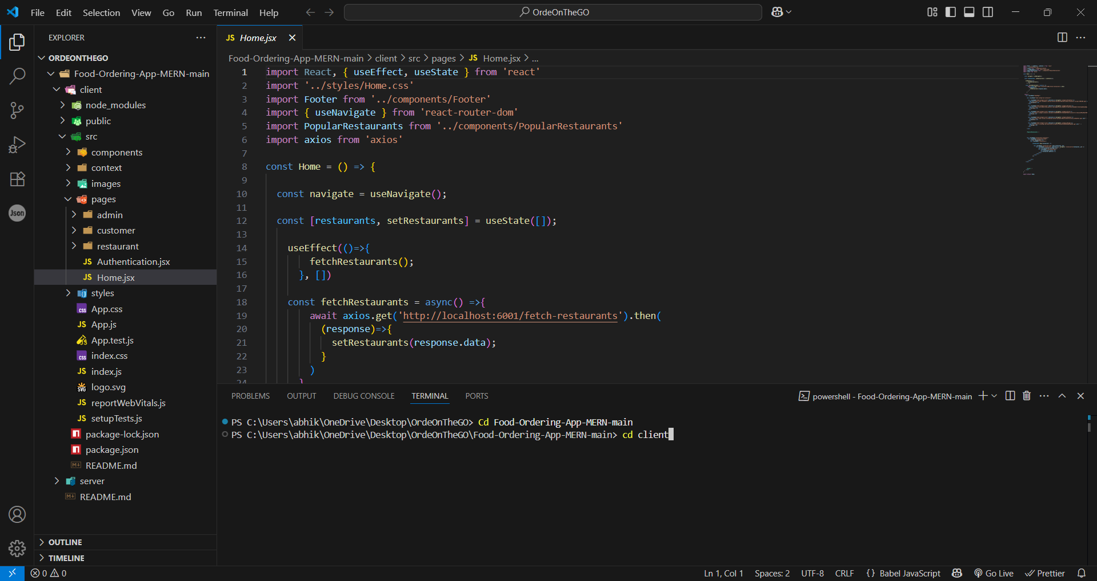

## 

**6.2 DATABASE DEVELOPMENT**

**Create database in cloud video link:-** <https://drive.google.com/file/d/1CQil5KzGnPvkVOPWTLP0h-Bu2bXhq7A3/view>

• Install Mongoose.

• Create database connection.

Reference Video of connect node with mongoDB database: <https://drive.google.com/file/d/1cTS3_-EOAAvDctkibG5zVikrTdmoY2Ag/view?usp=sharing>

Reference Article: <https://www.mongodb.com/docs/atlas/tutorial/connect-to-your-cluster/>

Reference Image:

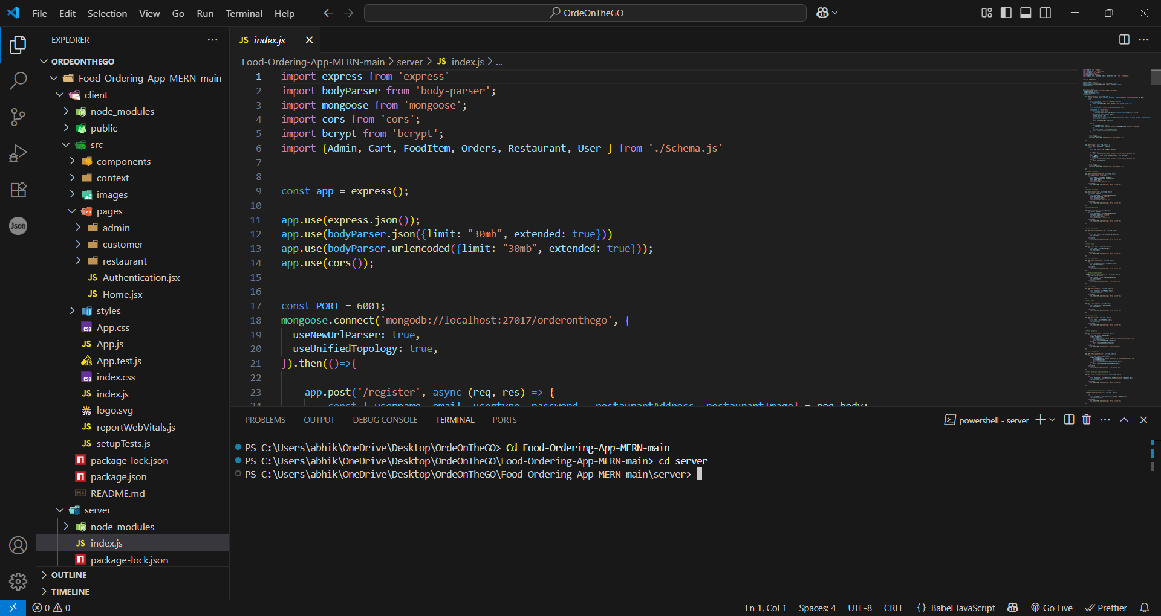

**Schema use-case:**

**1. User Schema:**

• Schema: userSchema

• Model: ‘User’

• The User schema represents the user data and includes fields such as username, email, and password.

**2. Product Schema:**

• Schema: productSchema

• Model: ‘Product’

• The Product schema represents the data of all the products in the platform.

• It is used to store information about the product details, which will later be useful for ordering.

**3. Orders Schema:**

• Schema: ordersSchema

• Model: ‘Orders’

• The Orders schema represents the orders data and includes fields such as userId, product Id, product name, quantity, size, order date, etc.,

**4. Cart Schema:**

• Schema: cartSchema

• Model: ‘Cart’

• The Cart schema represents the cart data and includes fields such as userId, product Id, product name, quantity, size, order date, etc.,

• The user Id field is a reference to the user who has the product in cart.

**5. Admin Schema:**

• Schema: adminSchema

• Model: ‘Admin’

• The admin schema has essential data such as categories, promoted restaurants, etc.,

**6. Restaurant Schema:**

• Schema: restaurantSchema

• Model: ‘Restaurant’

• The restaurant schema has the info about the restaurant and it’s menu

**Schemas:** Now let us define the required schemas

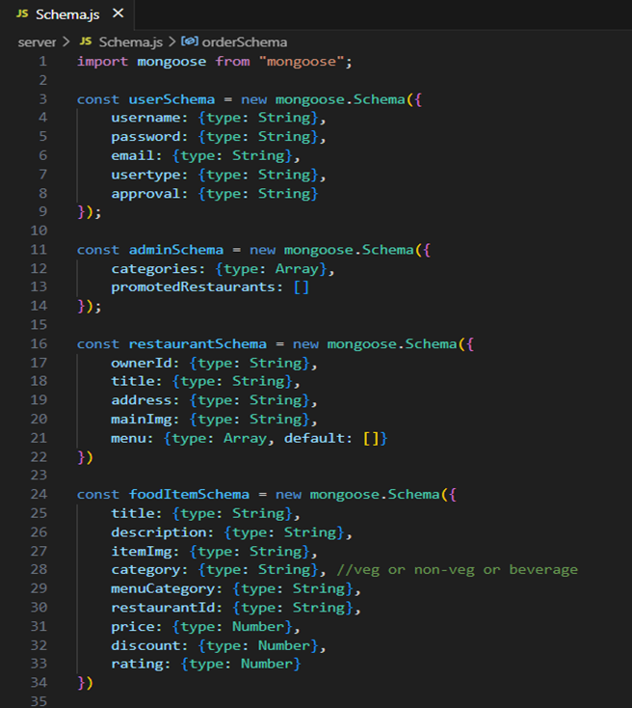

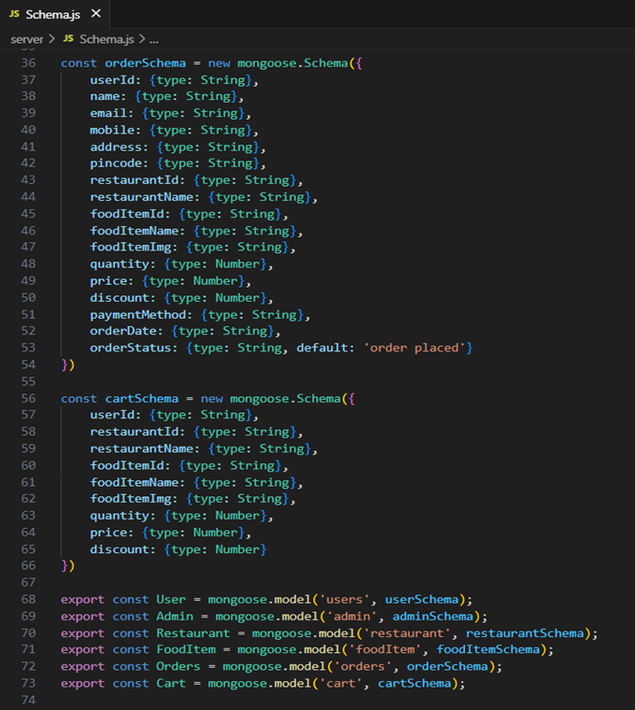

## 6.3 BACKEND DEVELOPMENT**:**

**Set Up Project Structure:**

• Create a new directory for your project and set up a package.json file using the npm init command.

• Install necessary dependencies such as Express.js, Mongoose, and other required packages.

Reference Video: <https://drive.google.com/file/d/19df7NU-gQK3DO6wr7ooAfJYIQwnemZoF/view?usp=sharing>

Reference Image:

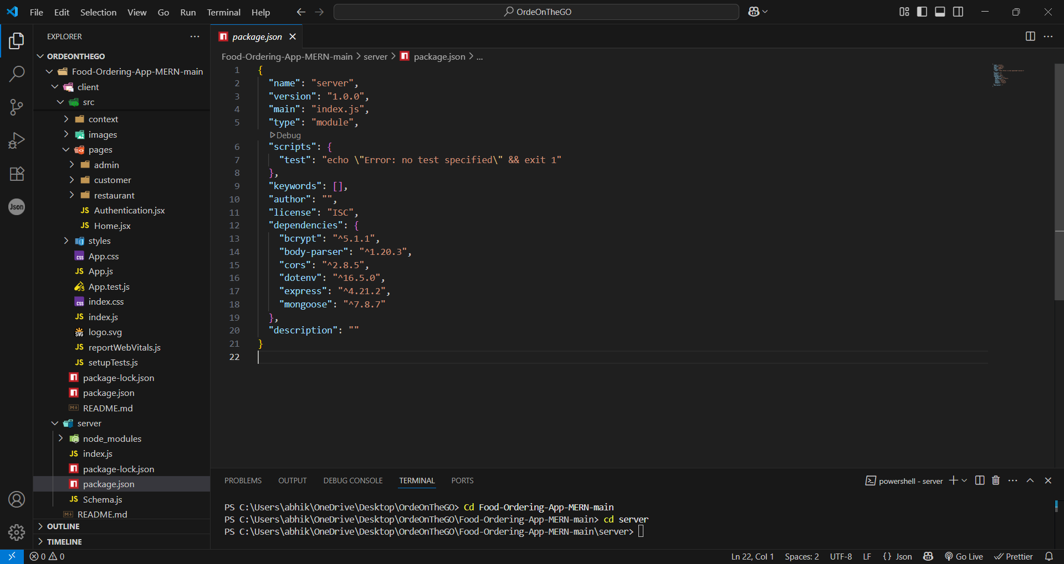

**6.3.1. Setup express server:**

• Create index.js file.

• Create an express server on your desired port number.

• Define API’s

Reference Video: <https://drive.google.com/file/d/1-uKMIcrok_ROHyZl2vRORggrYRio2qXS/view?usp=sharing>

Reference Image:

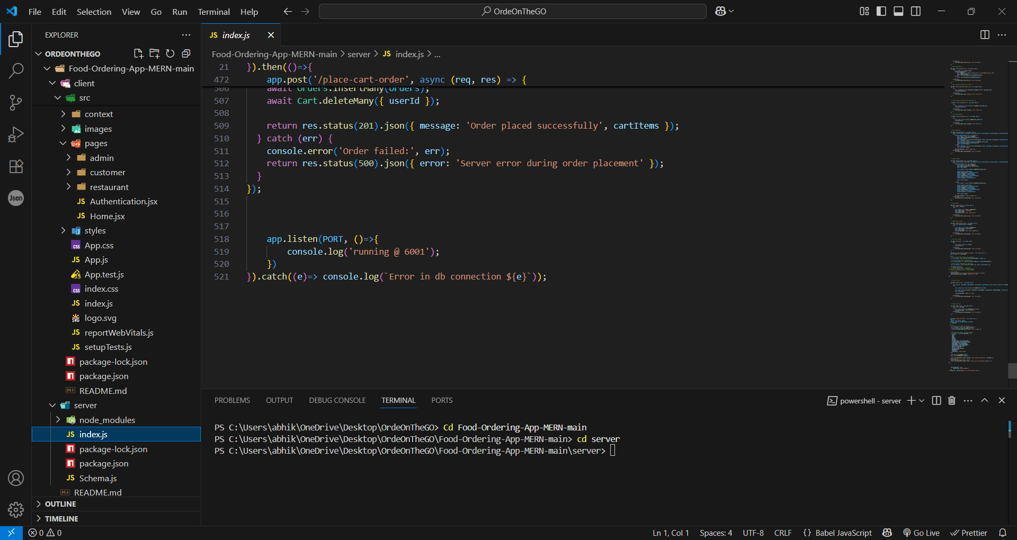

**6.3.2. Database Configuration:**

• Set up a MongoDB database either locally or using a cloud-based MongoDB service like MongoDB Atlas or use locally with MongoDB compass.

• Create a database and define the necessary collections for admin, users, restaurants, food products, orders,and other relevant data.

Reference Video of connect node with mongoDB database: <https://drive.google.com/file/d/1cTS3_-EOAAvDctkibG5zVikrTdmoY2Ag/view?usp=sharing>

Reference Article: <https://www.mongodb.com/docs/atlas/tutorial/connect-to-your-cluster/>

Reference Image:



**6.3.3. Create Express.js Server:**

• Set up an Express.js server to handle HTTP requests and serve API endpoints.

• Configure middleware such as body-parser for parsing request bodies and cors for handling cross-origin requests.

Reference Video: <https://drive.google.com/file/d/1-uKMIcrok_ROHyZl2vRORggrYRio2qXS/view?usp=sharing>

Reference Image:



**6.3.4. Define API Routes:**

• Create separate route files for different API functionalities such as users, orders, and authentication.

• Define the necessary routes for listing products, handling user registration and login,managing orders, etc.

• Implement route handlers using Express.js to handle requests and interact with the database.

**6.3.5. Implement Data Models:**

• Define Mongoose schemas for the different data entities like products, users, and orders.

• Create corresponding Mongoose models to interact with the MongoDB database.

• Implement CRUD operations (Create, Read, Update, Delete) for each model to perform database operations.

**6.3.6. User Authentication:**

• Create routes and middleware for user registration, login, and logout.

• Set up authentication middleware to protect routes that require user authentication.

**6.3.7. Handle new products and Orders:**

• Create routes and controllers to handle new product listings, including fetching products data from the database and sending it as a response.

• Implement ordering(buy) functionality by creating routes and controllers to handle order requests, including validation and database updates.

**6.3.8. Admin Functionality:**

• Implement routes and controllers specific to admin functionalities such as adding products, managing user orders, etc.

• Add necessary authentication and authorization checks to ensure only authorized admins can access these routes.

**6.3.9. Error Handling:**

• Implement error handling middleware to catch and handle any errors that occur during the API requests.

• Return appropriate error responses with relevant error messages and HTTP status codes.

## 6.4 FRONTEND DEVELOPMENT:

**6.4.1. Setup React Application:**

• Create a React app in the client folder.

• Install required libraries

• Create required pages and components and add routes.

**6.4.2.Design UI components:**

• Create Components.

• Implement layout and styling.

• Add navigation.

**6.4.3.Implement frontend logic:**

• Integration with API endpoints.

• Implement data binding.

Reference Video Link:

<https://drive.google.com/file/d/1EokogagcLMUGiIluwHGYQo65x8GRpDcP/view?usp=sharing>

Reference Article Link:

<https://www.w3schools.com/react/react_getstarted.asp>

Reference Image:

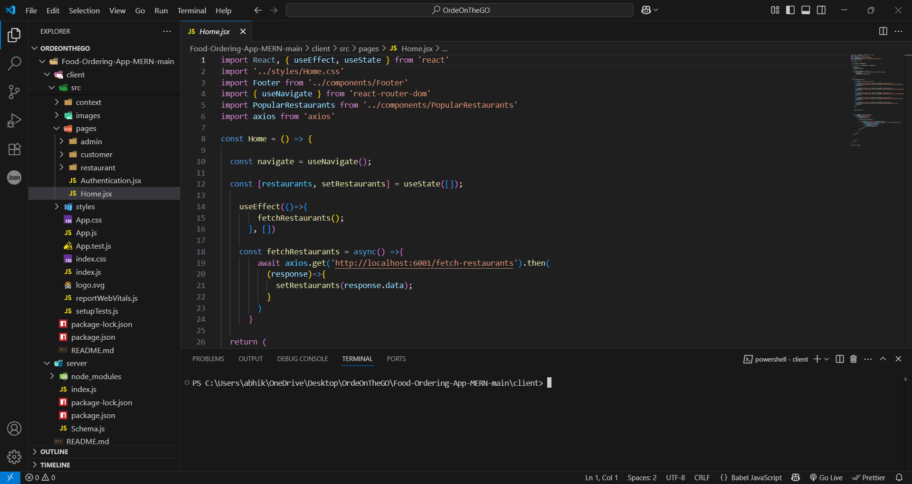

## 

## 6.5 CODE EXPLANATION

Server setup:

Let us import all the required tools/libraries and connect the database.

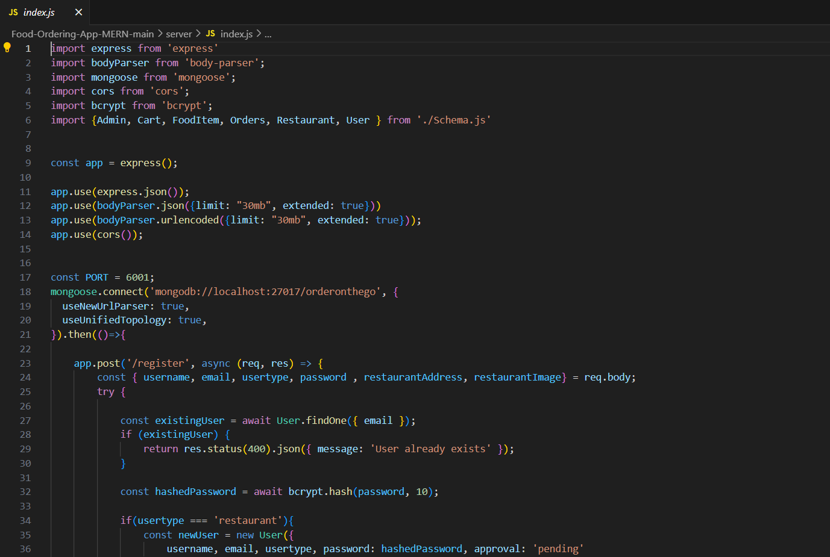

## API DOCUMENTATION

Here's a sample API Documentation section for OrderOnTheGo project backend:

All endpoints follow the base URL:  
https://your-backend-url.com/api

**1. User Authentication**

POST /auth/register

Registers a new user (Customer, Restaurant, Admin)

Body Parameters:

{

"role": "customer",

"email": "user@example.com",

"password": "123456"

}

Response:

{

"message": "User registered successfully"

}

POST /auth/login

Logs in a user

Body Parameters:

{

"email": "user@example.com",

"password": "123456"

}

Response:

{

"token": "jwt-token",

"user": {

"id": "userId",

"role": "customer"

}

}

**2. Restaurant APIs**

GET /restaurants

Get all restaurants

Response:

[

{

"id": "rest1",

"name": "SB Foods",

"category": "Indian",

"rating": 4.5

}

]

POST /restaurants

Add new restaurant (Admin only)

Body Parameters:

{

"name": "AHO Foods",

"category": "Chinese"

}

3. Food Items

GET /fooditems/:restaurantId

Get all food items for a restaurant

POST /fooditems

Add food item (Restaurant role)

Body Parameters:

{

"restaurantId": "rest1",

"name": "Chicken Pizza",

"price": 250,

"discount": 10,

"rating": 4.2

}

**4. Cart**

GET /cart/:userId

Get user's cart items

POST /cart

Add item to cart

Body Parameters:

{

"userId": "cust1",

"foodItemId": "item123",

"quantity": 2

}

DELETE /cart/:cartItemId

Remove item from cart

**5. Orders**

POST /orders

Place an order

Body Parameters:

{

"userId": "cust1",

"items": [

{

"foodItemId": "item123",

"quantity": 2

}

],

"payment": "COD"

}

GET /orders/user/:userId

Get all orders placed by a user

GET /orders/restaurant/:restaurantId

Get all orders received by a restaurant

**6. Invoice**

GET /invoice/:orderId

Download invoice as PDF

Response: File download

## 8.AUTHENTICATION

**User Authentication:**

**· Backend**

Now, here we define the functions to handle http requests from the client for authentication.

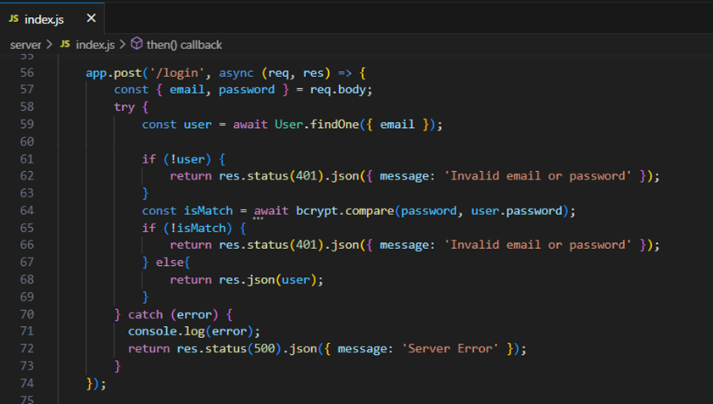

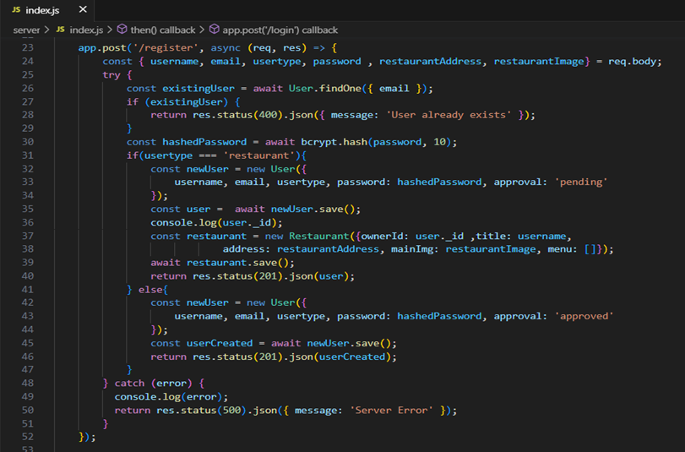

· **Frontend**

Login:

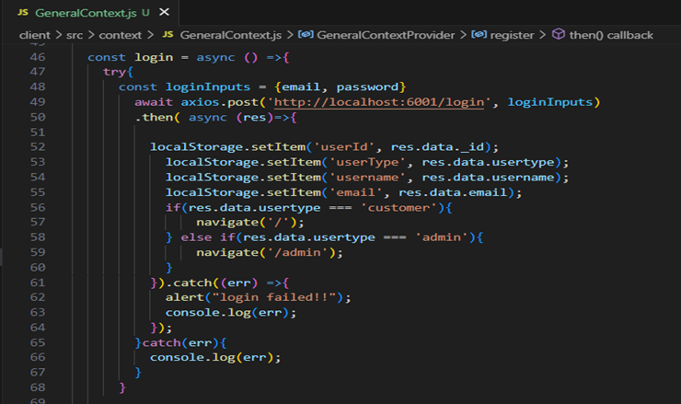

Logout:

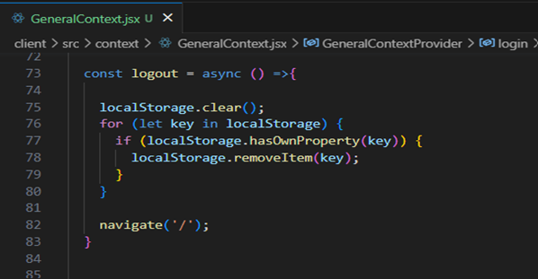

Register:

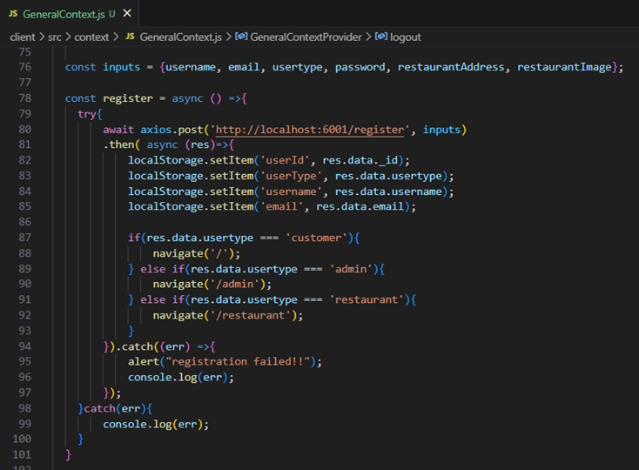

**All Products (User):**

· Frontend

In the home page, we’ll fetch all the products available in the platform along with the filters.

Fetching food items:

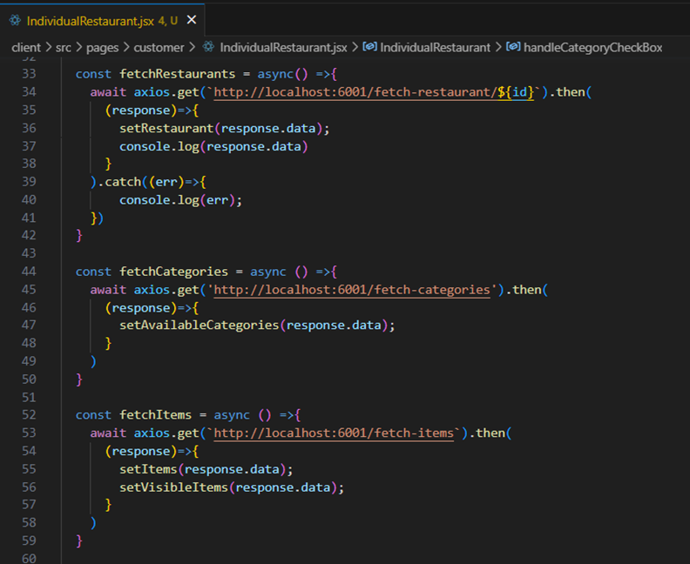

Filtering products:

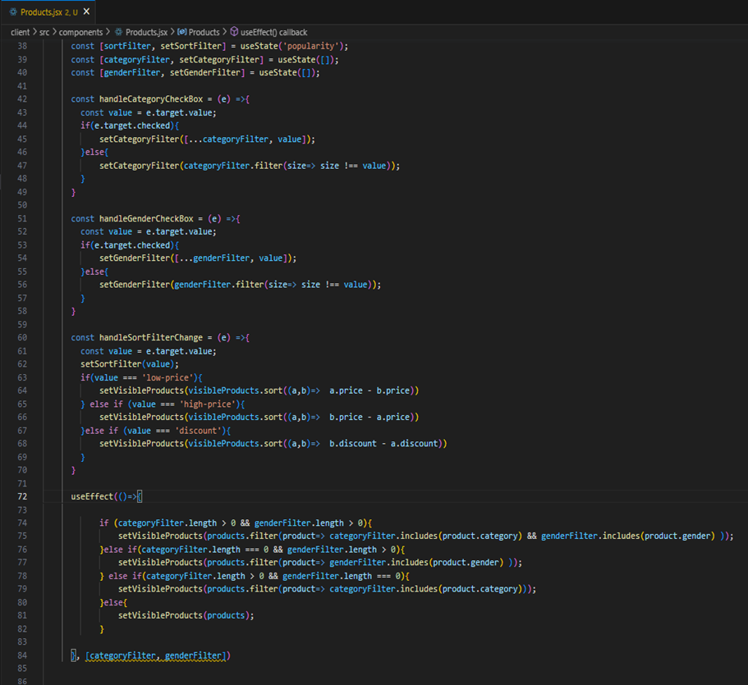

**· Backend**

In the backend, we fetch all the products and then filter them on the client side.

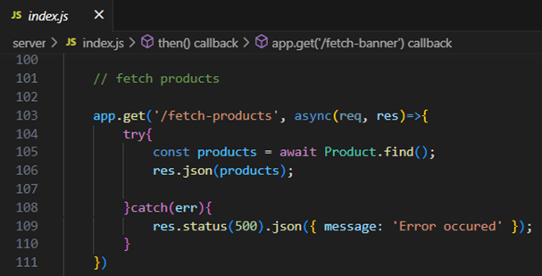

**Add product to cart:**

· **Frontend**

Here, we can add the product to the cart and later can buy them.

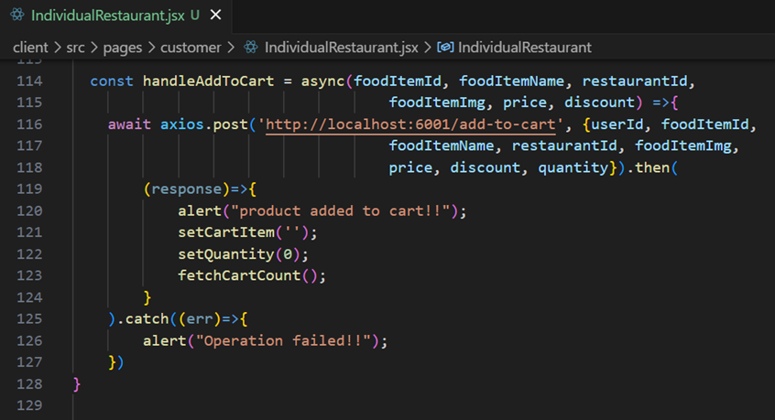

**· Backend**

Add product to cart:

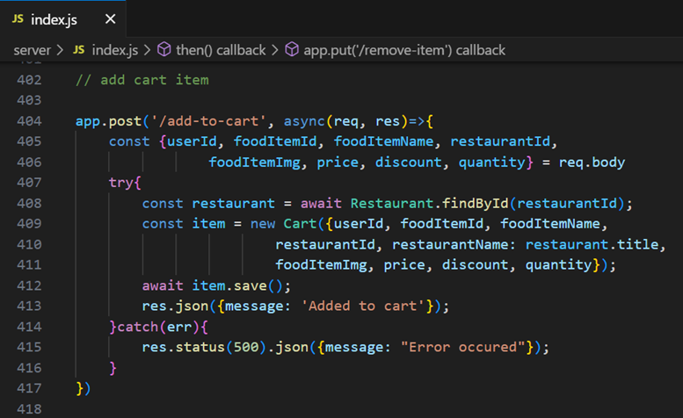

**Order products:**

Now, from the cart, let’s place the order

· Frontend

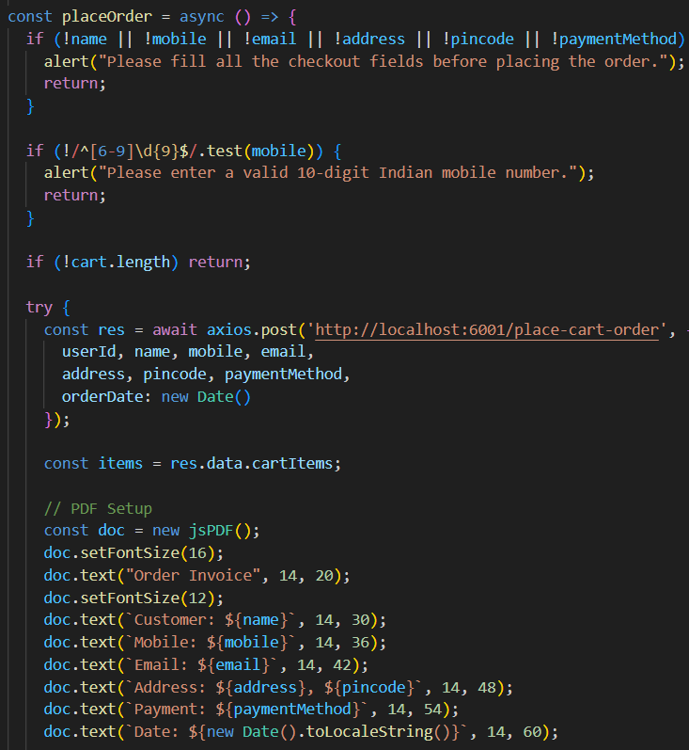

· **Backend**

In the backend, on receiving the request from the client, we then place the order for the products in the cart with the specific user Id.

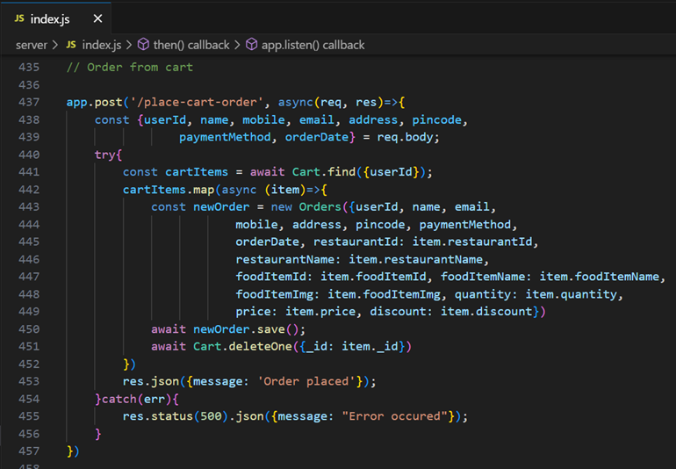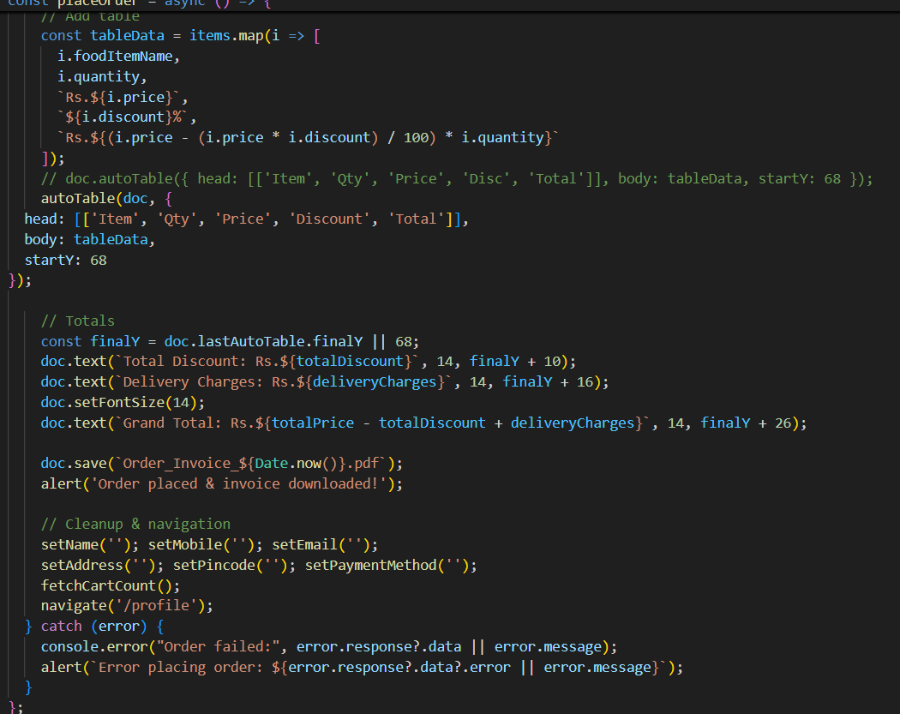

**Add new product:**

Here, in the admin dashboard, we will add a new product.

· Frontend:

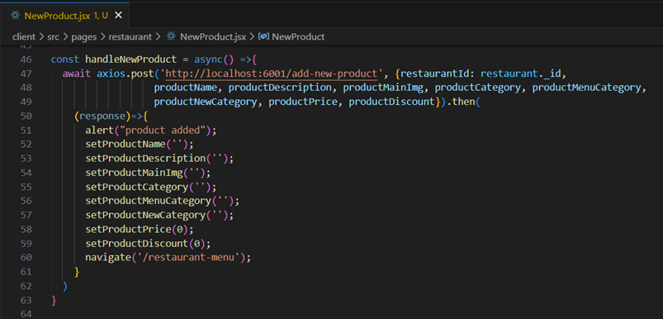

· **Backend:**

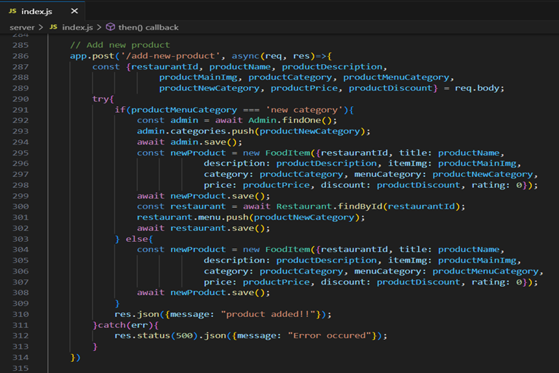

Along with this, implement additional features to view all orders, products, etc., in the admin dashboard.

## 9.USER INTERFACE

**1. Design Theme**

* Light Theme with soft backgrounds
* Clean layout, large clickable buttons
* Responsive design (works on desktops, tablets, mobiles)
* Smooth animations and transitions for a modern feel

**2. Customer Interface**

* Home Page: Explore restaurant categories (e.g., Indian, Fast Food, Chinese)
* Restaurant List: Displays restaurant cards with name, rating, and category
* Menu Page: View food items with name, price, rating, discount, and “Add to Cart” button
* Cart Page: View added items
* Place order
* Order Confirmation: Shows success message and download invoice button
* Order History Page: View past orders with details

**3. Restaurant Interface**

* Dashboard: Overview of new and active orders
* Menu Management: Add/Edit/Delete food items
* Set price, rating, and availability
* Order List: View incoming orders with customer details
* Update order status

**4. Admin Interface**

Admin Panel:

* View list of users (customers/restaurants)
* Remove/block users
* Monitor total orders, system activity

**5. UI Features**

* Navigation Bar: Role-based dynamic links (e.g., Cart for customers, Dashboard for restaurants)
* Toast Notifications: Success and error messages for actions (e.g., "Item added to cart", "Login failed")
* Modals: For confirmation actions (e.g., deleting food item, placing order)
* Forms: Styled and validated for login, registration, add food, etc.

## TESTING

## 10.1 Testing

The testing approach in OrderOnTheGo focused on validating functionality, reliability, and role-based access across all major user flows. The strategy was executed in the following phases:

**1. Manual Testing**

Primary strategy during development

All core features tested manually (e.g., registration, order placement, invoice generation)

**2. Functional Testing**

Verified that all endpoints and UI components function as intended

Focused on each role (Customer, Restaurant, Admin) independently

**3. User Acceptance Testing (UAT)**

Conducted at the end of development

Real-world scenarios used to validate the project against user expectations

**4. Role-Based Testing**

Ensured that users only access allowed functionalities

Example: Customers cannot access restaurant dashboards

**5. Black Box Testing**

Inputs and outputs tested without checking internal logic

Applied to modules like login, add to cart, place order, etc.

## 10.2 Tools used

**1. Postman**

Used for API testing and verification

Validated response codes, payloads, and error handling for endpoints like /login, /orders, /fooditems

**2. Browser DevTools (Chrome/Edge)**

Inspected frontend rendering

Checked for network errors, response time, and responsiveness

**3. VS Code Debugger**

Tracked console errors during local development

Ensured proper flow of data between frontend and backend

**4. Manual Checklists**

Test cases were written and marked manually

Covered positive/negative cases and edge scenarios (e.g., empty cart, invalid credentials)

**5. PDF Invoice Viewer**

Tested generated invoices for accuracy and readability using built-in browser PDF viewer

## 11.SCREENSHOTS AND DEMO

· **Landing page**

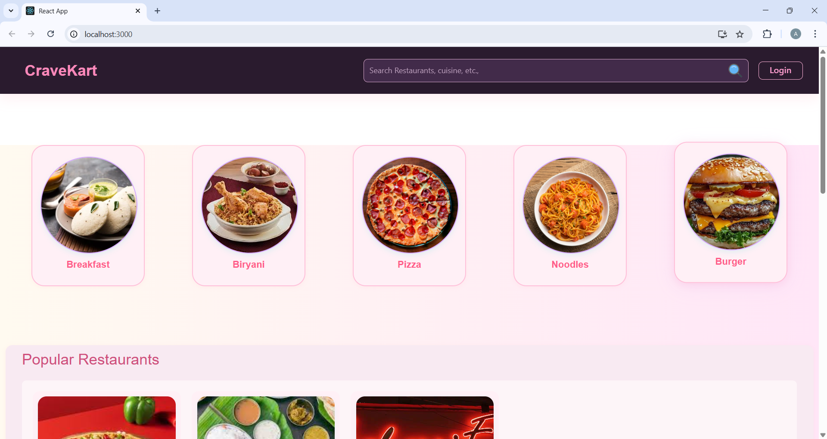

· **Restaurants**

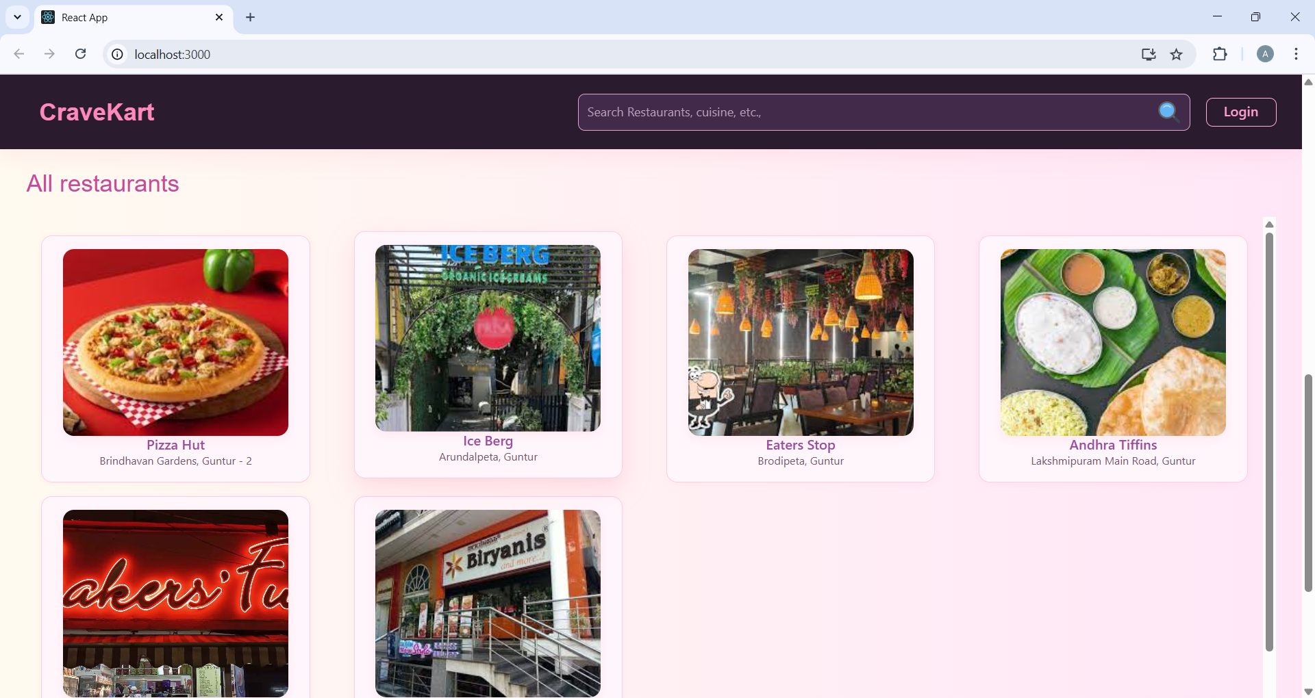

· **Restaurant Menu**

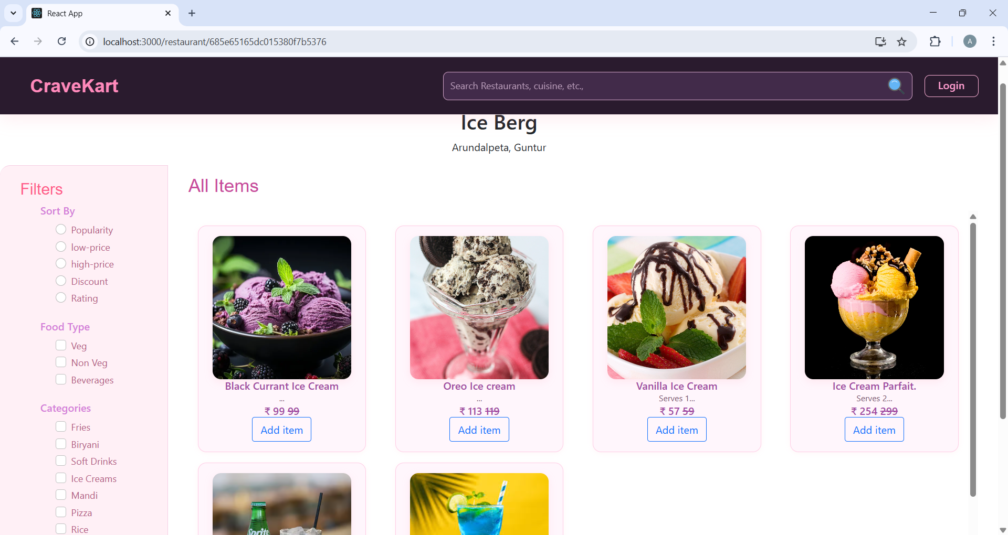

· **Authentication**

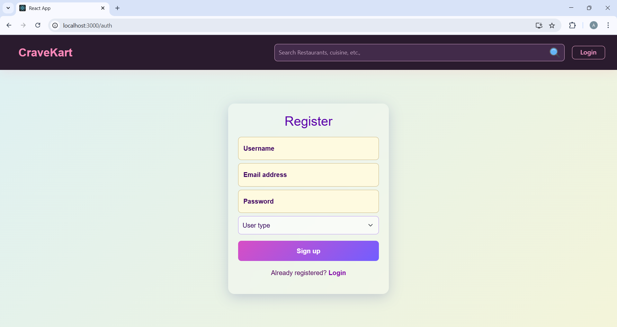

· **User Profile**

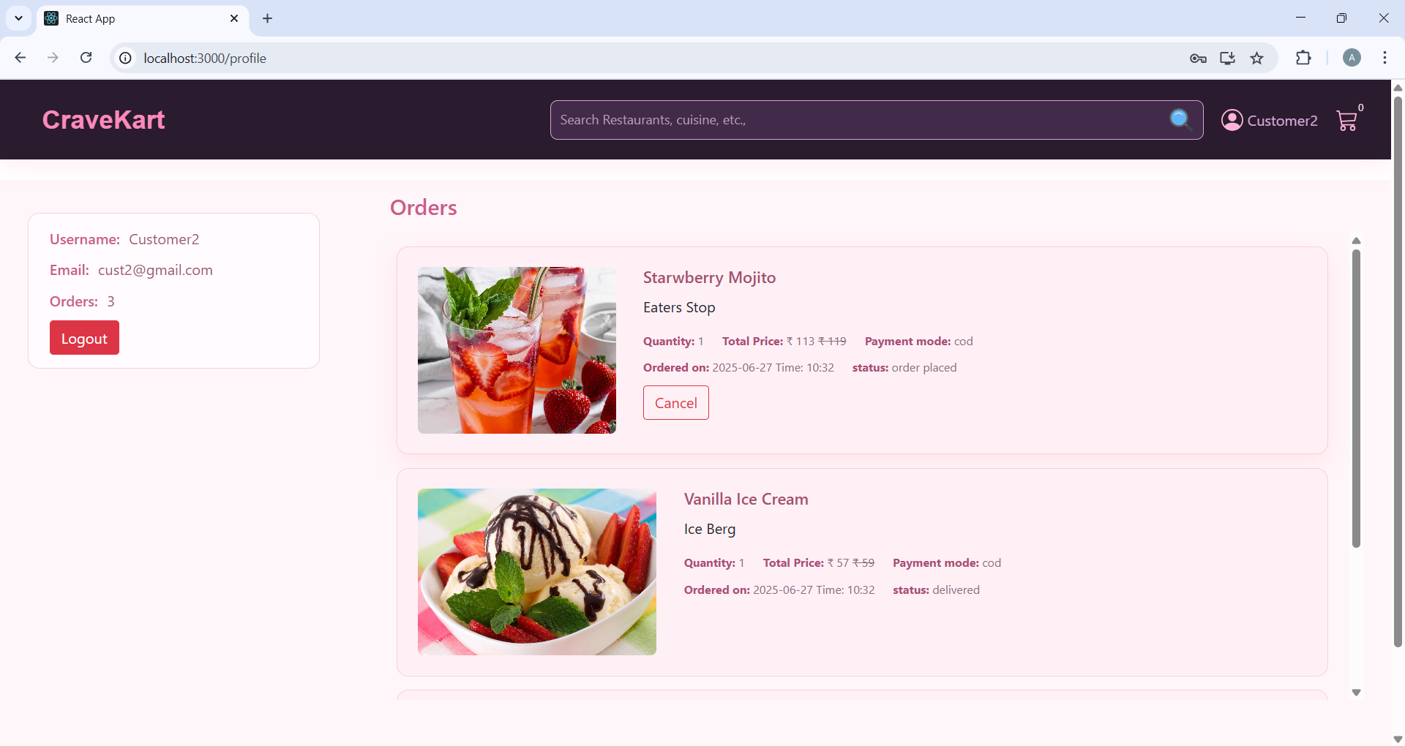

**· Cart**

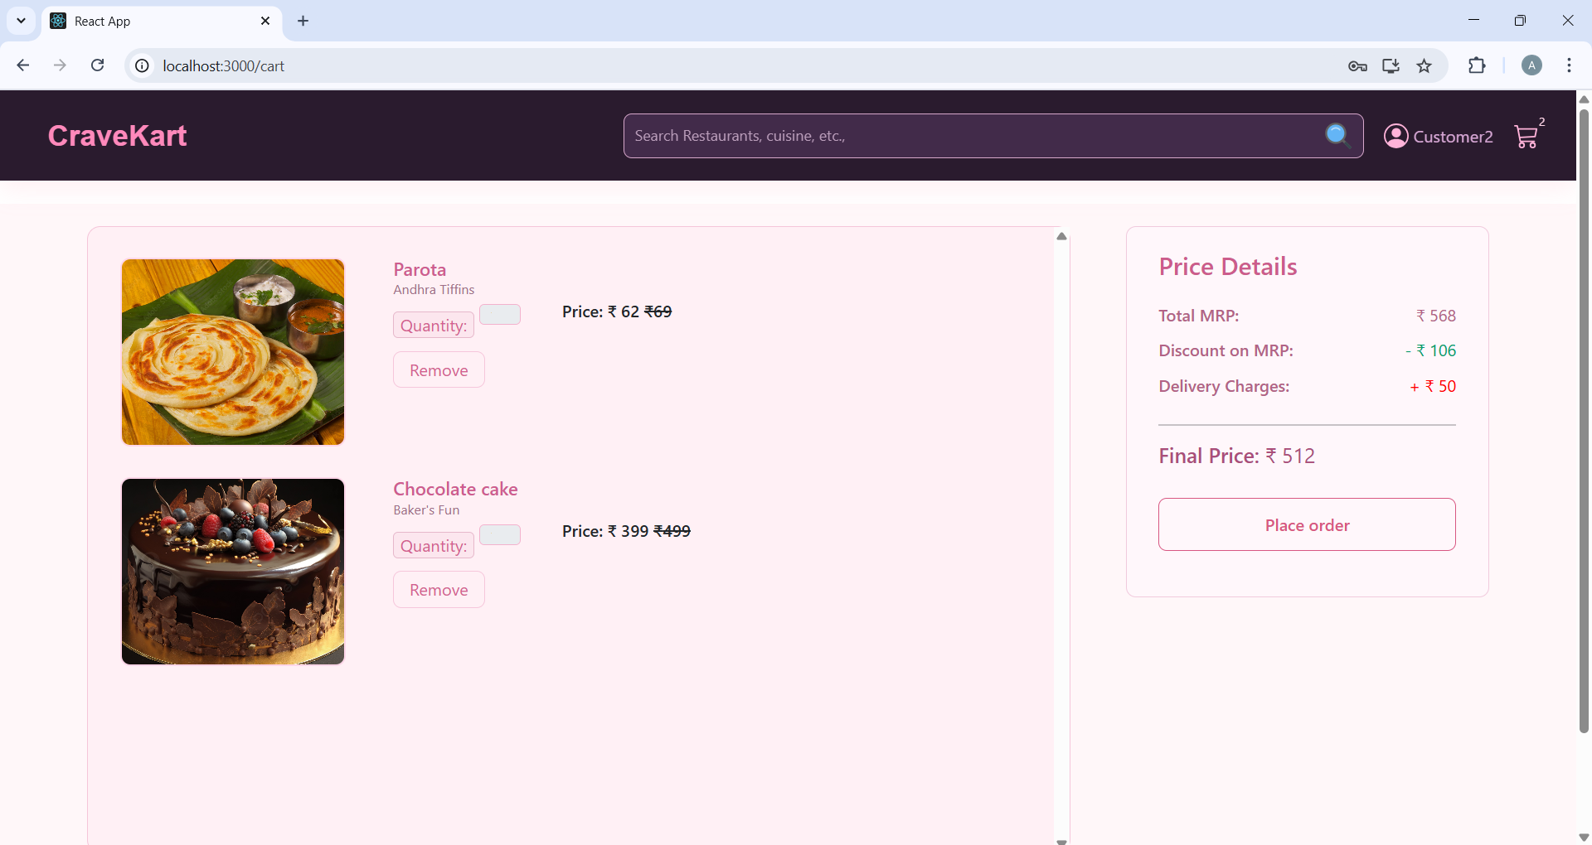

**· Checkout details**

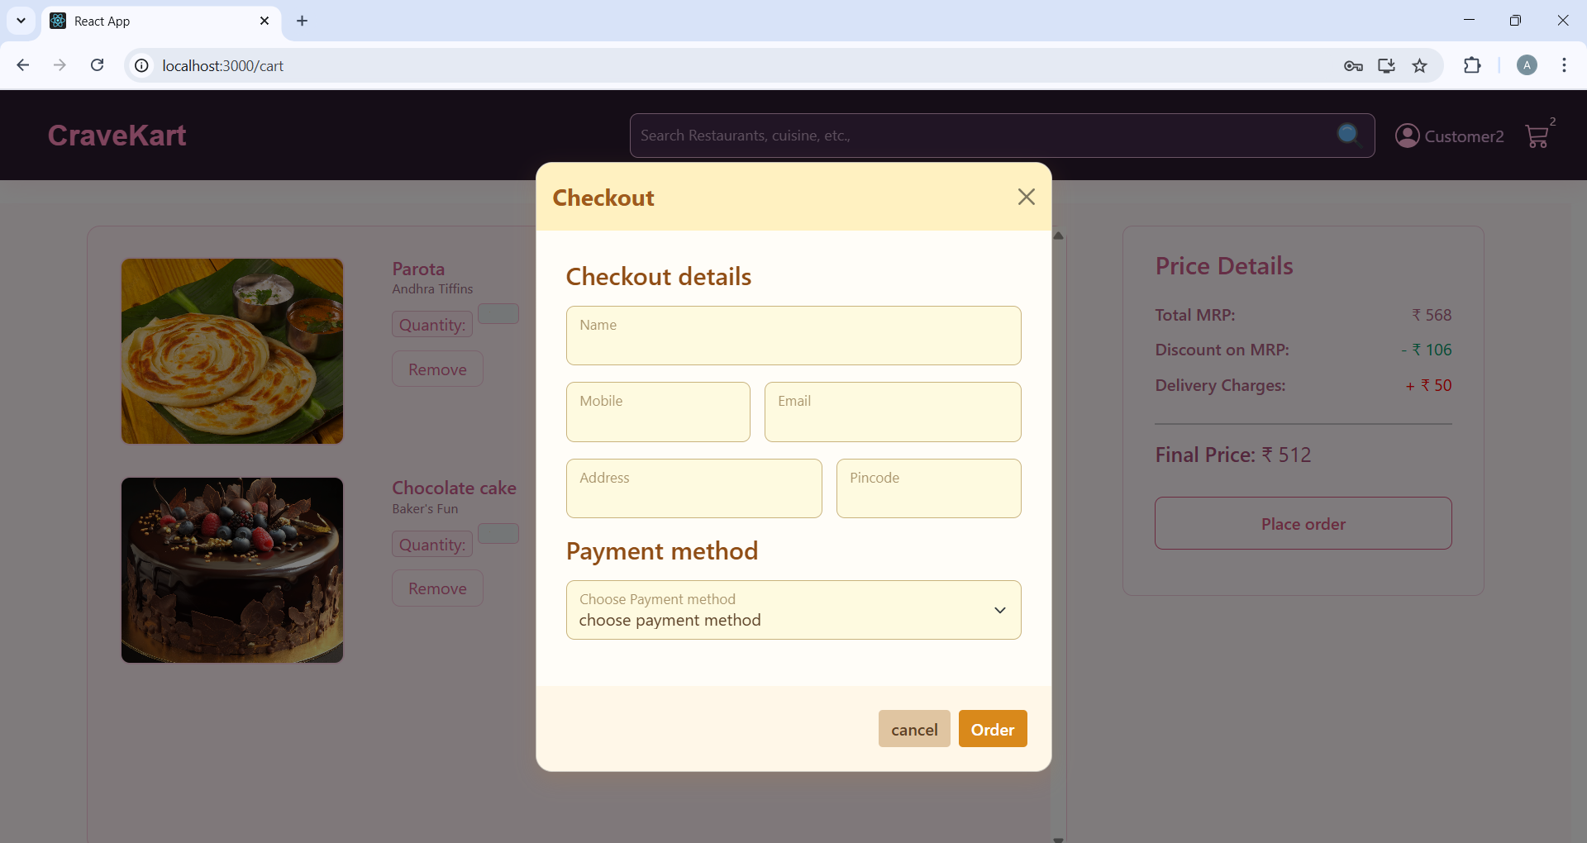

**· Invoice Download**

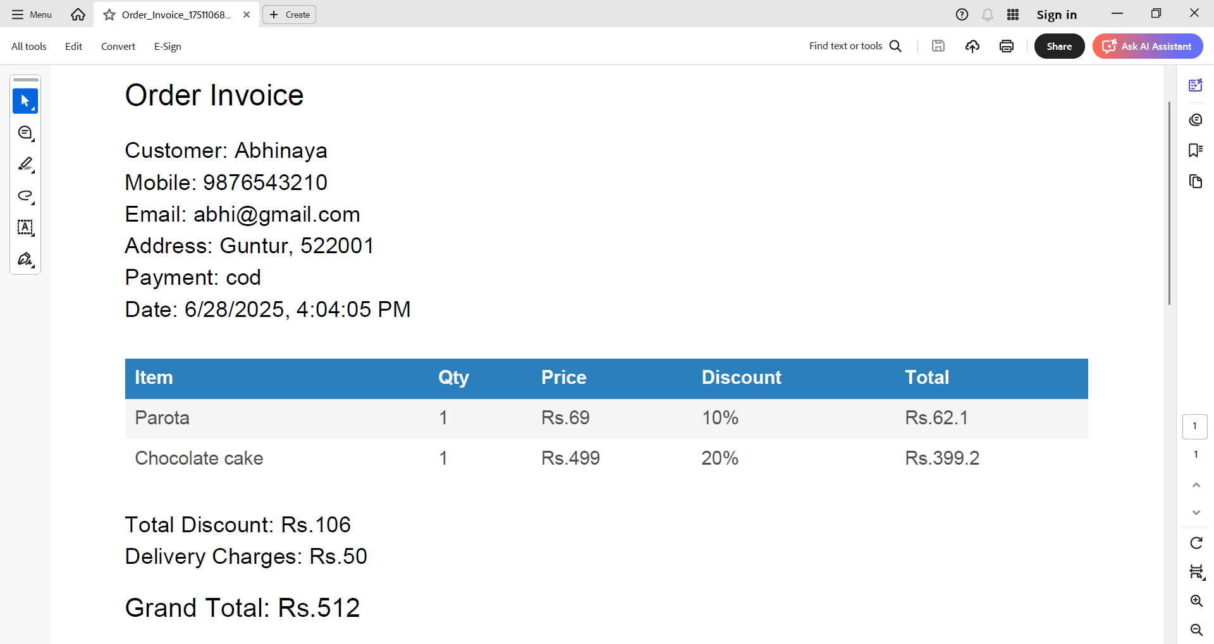

**· Admin dashboard**

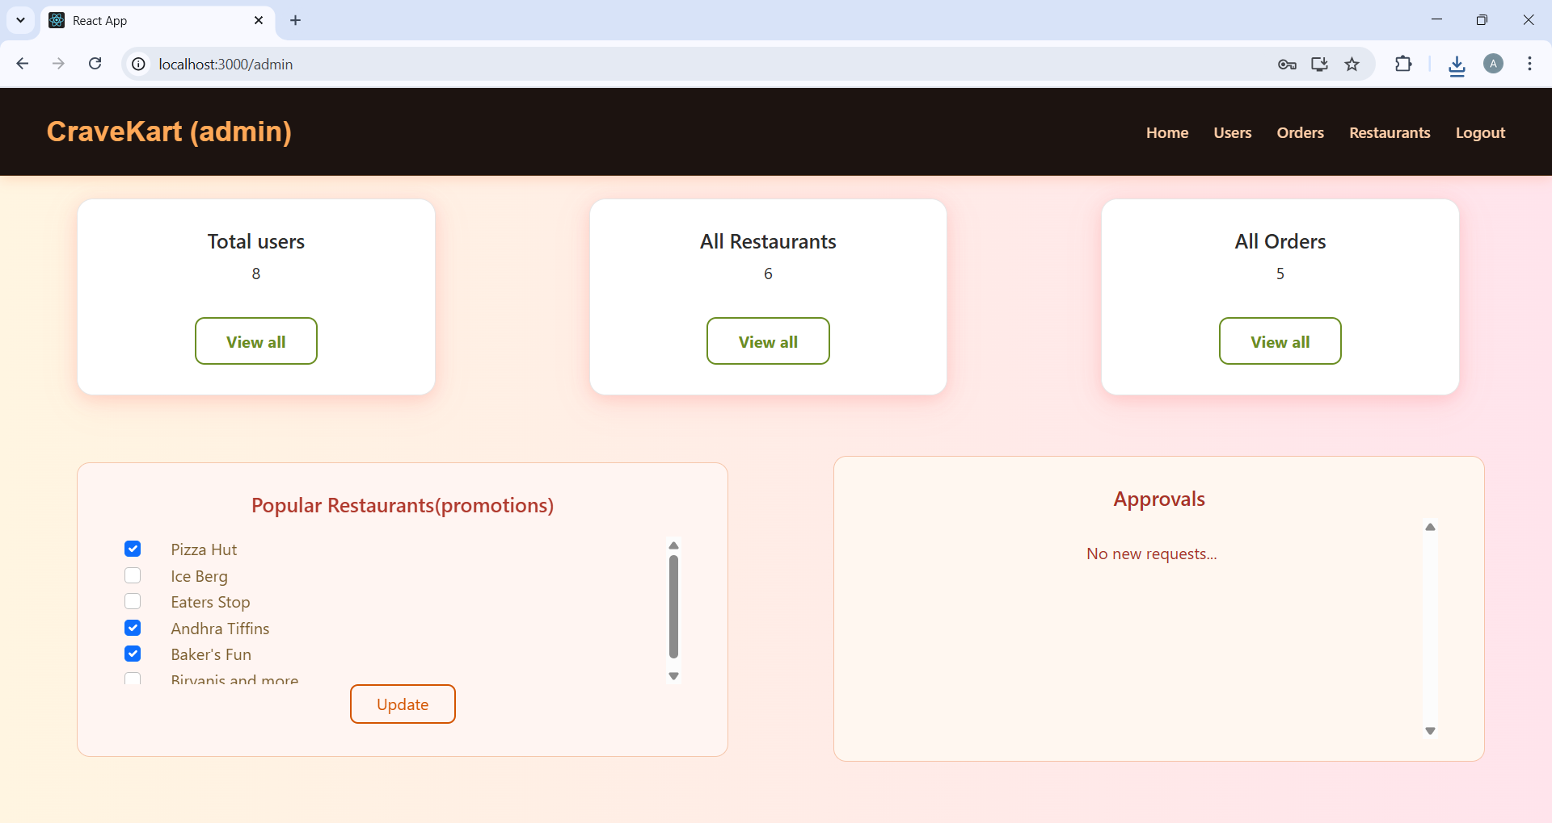

**· All Orders**

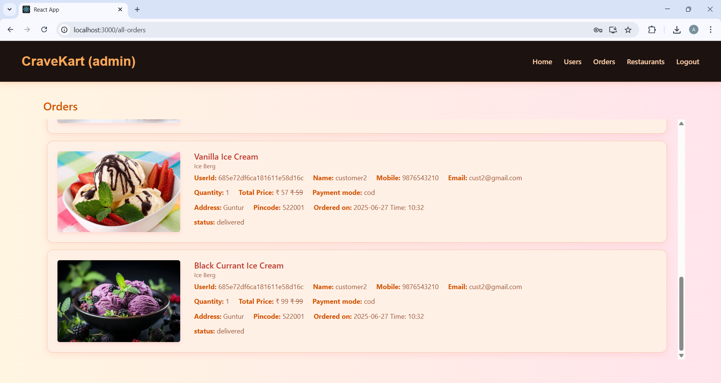

**· All restaurants**

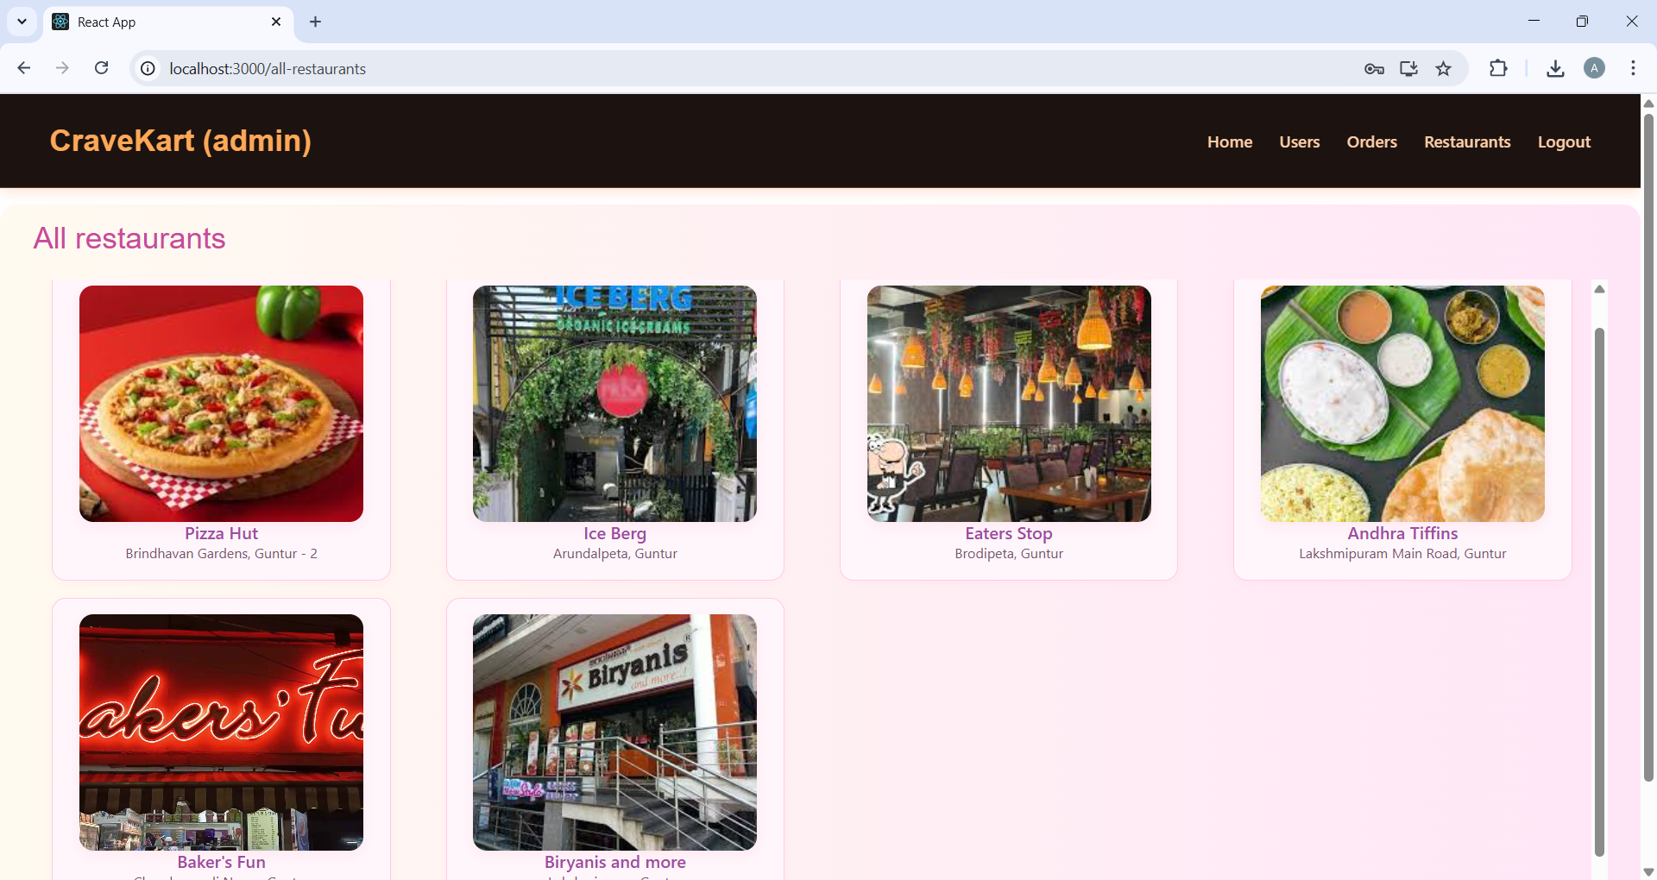

**· Restaurant Dashboard**

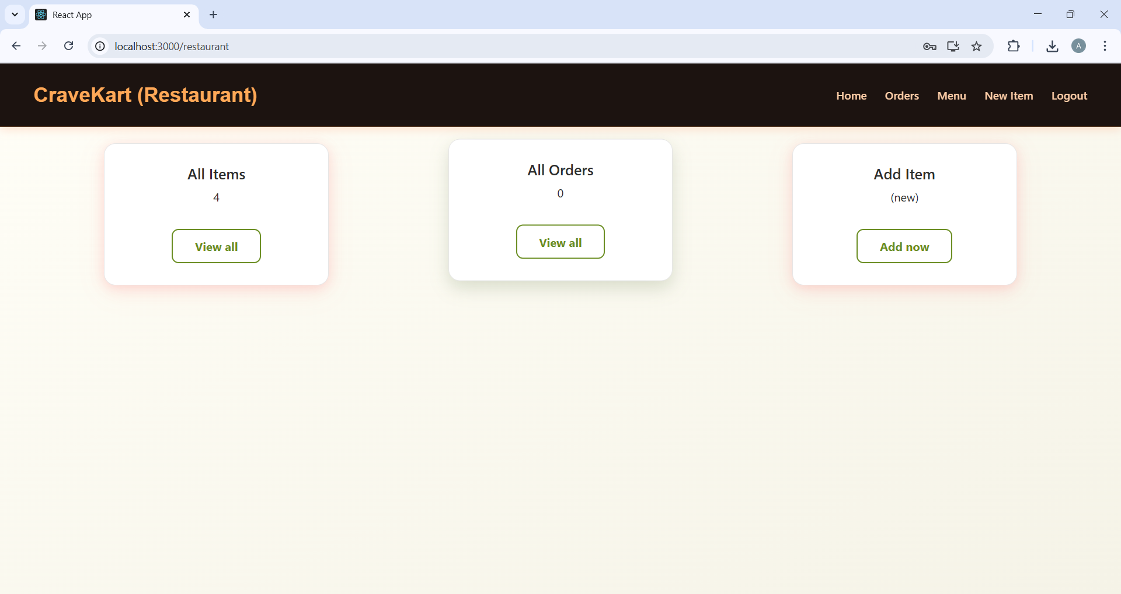

**· New Item**

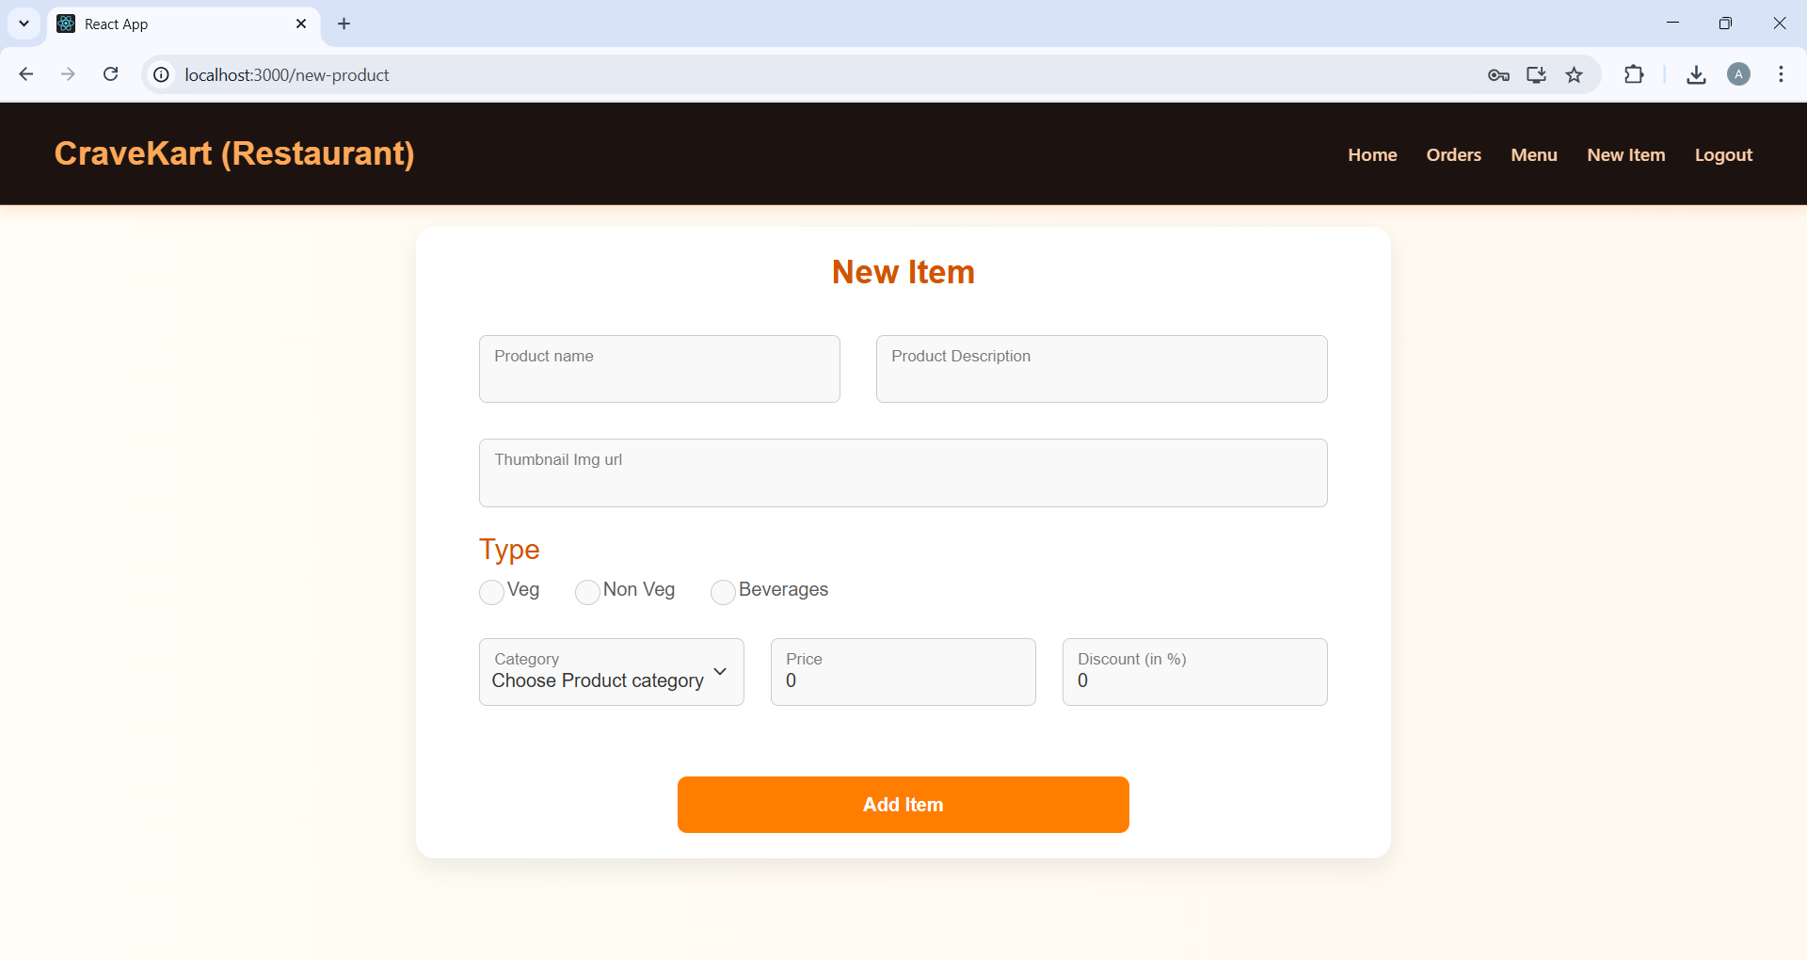

All Items

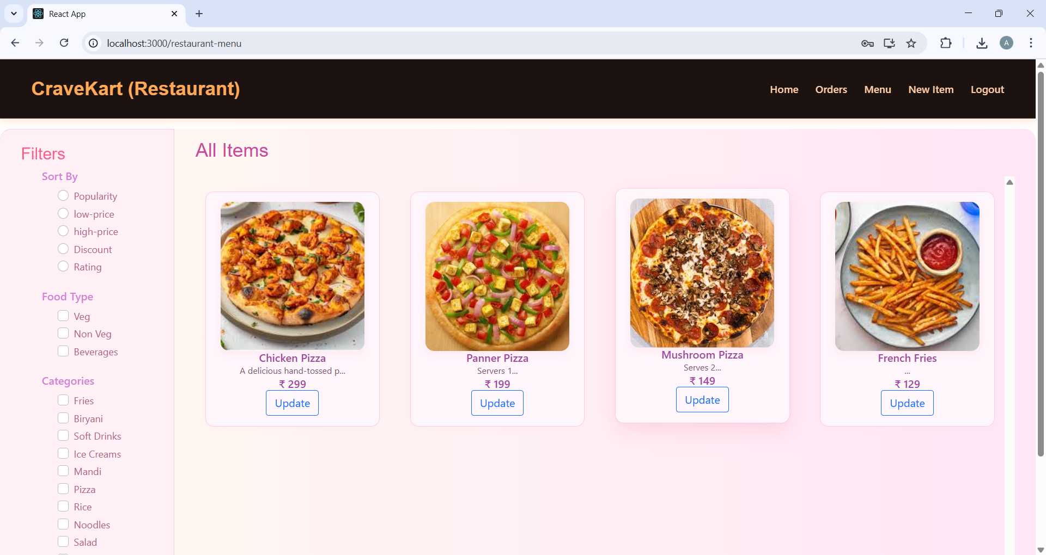

For any further doubts or help, please consider the GitHub repo,

<https://github.com/KalisettyAbhi234/OrderOnTheGo-Your-On-Demand-Food-Ordering-Solution/tree/main>

The demo of the app is available at:

https://drive.google.com/file/d/1aT5kXVJX83ht5Yap2FwRCRcOqnS3_Mxb/view?usp=sharing

## KNOWN ISSUES

Below are the currently identified bugs and limitations in the application that are yet to be resolved or are under monitoring.

**Customer Side**

1. Invoice Download Naming

* Issue: Invoices are downloaded with random filenames.
* Impact: May confuse users managing multiple orders.
* Status: Improvement planned (add OrderID or date in filename).

1. No UPI or Online Payment Integration

* Issue: Only Cash on Delivery (COD) is supported.
* Impact: May reduce convenience for online-first users.
* Status: Planned for next release.

**Restaurant Side**

1. Image Upload Without Preview

* Issue: No real-time image preview when adding food items.
* Impact: Can lead to incorrect uploads.
* Status: Under development.

1. Order Status Update Not Real-Time

* Issue: Status changes are not auto-refreshed.
* Impact: Restaurant must manually reload to see new orders.
* Status: To be improved using WebSockets or polling.

**Admin Side**

1. Limited Analytics

* Issue: Admin dashboard lacks graphs/stats of user and order data.
* Impact: Makes system monitoring less effective.
* Status: Feature planned in future roadmap.

## FUTURE ENHANCEMENTS

These features are planned for future development to improve user experience, functionality, and scalability.

**1. Online Payment Integration**

Integrate UPI, debit/credit card, and wallet payment gateways (e.g., Razorpay, Stripe)

Support for multiple payment methods instead of only COD

**2. Real-Time Order Notifications**

Use WebSockets or Firebase to notify users and restaurants about order status updates instantly

Improve responsiveness for both customers and restaurant owners

**3. Live Order Tracking**

Enable customers to track delivery agents and estimated delivery time

Integrate Google Maps API for live tracking interface

**4. Mobile App Version**

Develop native or hybrid Android/iOS app using React Native or Flutter

Push notifications for offers and order updates

**5. Admin Analytics Dashboard**

Add visual charts and reports for admins to monitor:

Total users, orders, revenue trends

Top-performing restaurants and food items

**6. Reviews & Ratings System**

Allow users to rate food items and restaurants

Display average ratings for better decision making

**7. Multi-language Support**

Support regional and international languages

Expand accessibility and localization

**8. Automated Testing**

Integrate unit testing (Jest) and E2E testing (Cypress)

Enable CI/CD pipelines for seamless updates